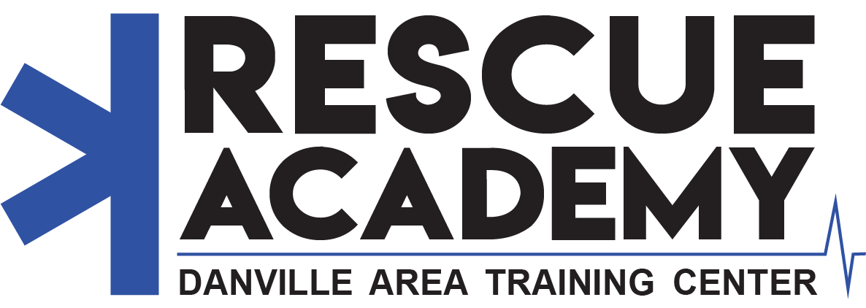

RECRUIT ACADEMY STUDENT APPLICATION

Please complete the following form and email it to balderson@datc.training or deliver it to the Danville Area Training Center by July 26, 2023. The Rescue Academy starts in October 2023 and runs until May 2024. Classes will be from 6:00pm – 9:00pm.

- Full Name: First Middle Last
- Nick Name: Name
- Date of Birth: 00/00/00 SSN: XXX-XX-XXXX

- Address: Mailing Address

- Phone: (Home) (XXX)-XXX-XXXX (Work) (XXX)-XXX-XXXX (Cell) (XXX)-XXX-XXXX

- Email: email@email.com

- Normal Working Hours: 00:00 – 00:00

- Do you have a valid driver’s license?
  - ☐Yes ☐No
  - What State?
  - License Number: XXXXXXXXX

- Military Record: (If your answer to question “A” is negative, you may omit the rest of this section)

  - Have you ever served on active duty in the armed services of the United States?
☐Yes ☐No
  - What Branch? Branch of Military
  - Dates of Service: 00/00/0000 – 00/00/0000
  - Serial Number: XXXXXXXXXX
  - Are you now a member of The Reserves or National Guard? ☐Yes ☐No
  - If in the Guard, who is your Lieutenant in charge? First Middle Last
- Have you ever been arrested or charged by summons or otherwise with any law violations as an adult? If so, list incidents below. (Do not include parking tickets).

Date | Place | Charge | Disposition | Details
00/00/00 | State | Charge | Disposition | Details
00/00/00 | State | Charge | Disposition | Details
00/00/00 | State | Charge | Disposition | Details
00/00/00 | State | Charge | Disposition | Details
00/00/00 | State | Charge | Disposition | Details

- Would you consent to random drug testing?
☐Yes ☐No

- Previous medical training:

CPR: EMT (Level):
EVOC: Vehicle Extrication:
Other Certifications:
- Emergency Contacts:

Name: First Last Relation:
Phone Number: (XXX)-XXX-XXXX
Address Home Address

Name: First Last Relation:
Phone Number: (XXX)-XXX-XXXX
Address Home Address

- Please list any known allergies or medical history that could affect your performance:

- This class requires participants to wear special clothing to participate. Please fill in the blank as accurately as possible to ensure proper fit of gear.
Shirt Size: Pants Size:
- Before any person is selected for membership in the Rescue Academy, all statements made in this application are thoroughly investigated. You may use the space below to explain any irregularities that may be disclosed by our investigation.

I hereby certify that all statements made by me on this application are true and complete, to the best of my knowledge. I understand that this form is an application for the Advanced EMT class, and the contents are held in strict confidence. I further understand that this application is intended to provide adequate background and reference information to the Danville Area Training Center.

☐ Yes, all statements are true and correct.

Signature: Date: 00/00/00

Questions or completed applications can be sent to balderson@datc.training or deliver it to the Danville Area Training Center by July 21, 2023.

Thank you for your interest!

