2025 #6 RECRUIT ACADEMY STUDENT APPLICATION

**Please complete the following form and email to** [**greeves@dlsc.org**](mailto:greeves@dlsc.org) **or deliver it to the Danville Area Training Center by July 28, 2025. The Recruit Academy is an apprenticeship program that will run Monday to Friday for 10 weeks. Class/work time will be 8:30am to 5:30pm.**

1. Full Name: Nick Name:
2. Date of Birth (00/00/00): SSN
3. Address:

_

_

1. Phone: (Home) (Work) (Cell)
2. Email:
3. Normal Working Hours:
4. Do you have a valid driver’s license?
   1. Yes No
   2. What State?
   3. License Number:
5. Military Record: *(If your answer to question “A” is negative, you may omit the rest of this section)*
   1. Have you ever served on active duty in the armed services of the United States?

Yes No

* 1. What Branch?
  2. Dates of Service:
  3. Serial Number:
  4. Are you now a member of The Reserves or National Guard Yes No
  5. If in the Guard, who is your Lieutenant in charge?

1. Have you ever been arrested or charged by summons or otherwise with any law violations as an adult? If so, list incidents below. *(Do not include parking tickets).*

Date Place Charge Disposition Details

|  |  |  |  |  |
| --- | --- | --- | --- | --- |
|  |  |  |  |  |
|  |  |  |  |  |
|  |  |  |  |  |
|  |  |  |  |  |
|  |  |  |  |  |

1. Will you consent to random drug testing?
2. Previous medical training:

Yes No

CPR EMT (Level) _ EVOC Vehicle Extrication Other Certifications: _

_

_

_

_

_

_

_

1. Emergency Contacts:

Name Relation Phone Number

Address

Name Relation Phone Number

Address

1. List any known allergies or medical history that could affect your performance:

_

_

1. List any DLSC and/or DATC personnel that you know and how you know them:

______________________________________________________________________________

______________________________________________________________________________

______________________________________________________________________________

______________________________________________________________________________

1. Before any person is selected for membership in the Recruit Academy, all statements made in this application are thoroughly investigated. You may use the space below to explain any irregularities that may be disclosed by our investigation.

I hereby certify that all statements made by me on this application are true and complete, to the best of my knowledge. I understand that this form is an application for the EMT class, and the contents are held in strict confidence. I further understand that this application is intended to provide adequate background and reference information to the Danville Area Training Center.

Yes, all statements are true and correct.

Signature: Date:

***Questions or completed applications can be sent to*** [***greeves@dlsc.org***](mailto:greeves@dlsc.org) ***or deliver it to the Danville Area Training Center by July 28, 2025.***

***Thank you for your interest!***

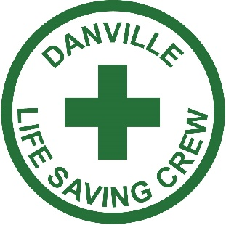**

**Received by DLSC/DATC: _________________ Date: ______________**